# Lab: C# Intro and Basic Syntax

Problems for exercises and homework for the [“Programming Fundamentals Extended” course @ SoftUni](https://softuni.bg/courses/programming-fundamentals).

## Greeting

Write a program, which **greets** the user by their **name**, which it **reads** from the **console**.

### Create a New C# Project, using Visual Studio

Open **Visual Studio** and create a new project by going into **[File 🡪 New 🡪 Project]**:

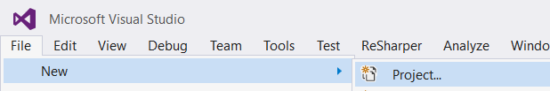

After that, the project creation window will open.

Select **Visual C#**, then **Console Application** and name it appropriately:

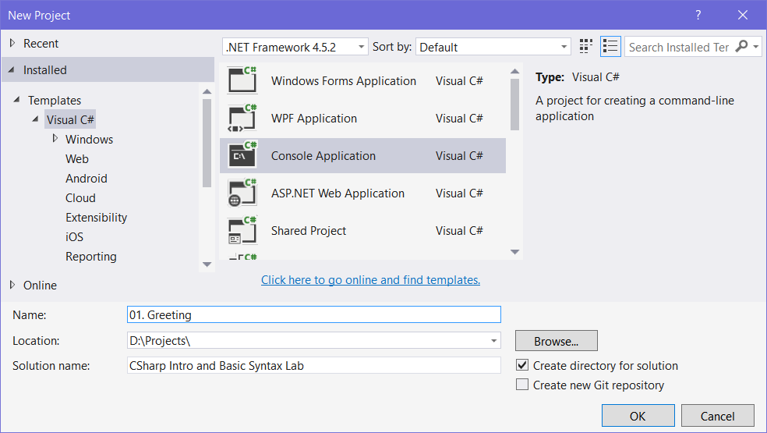

### Write the Program Logic

A new file opens in the editor, which looks like this:

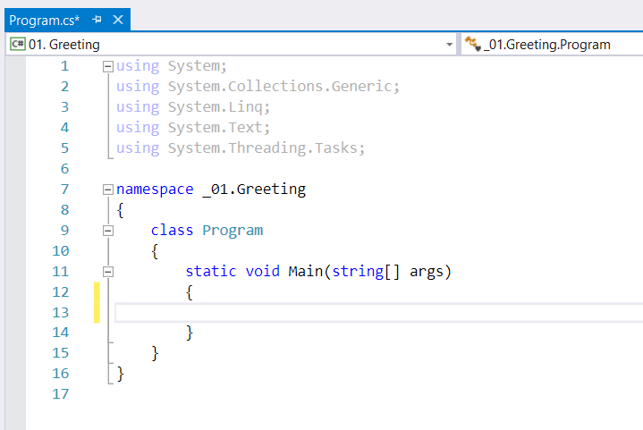

Let’s write the program logic. We want to **read** a name and then **print** that name with some additional text on the **console**. To accomplish this, we’ll use Console.ReadLine() and Console.WriteLine():

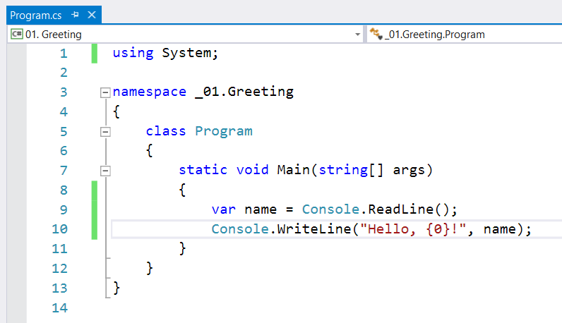

### Test the Program

After we wrote the program logic, we can **start** our program, using [Ctrl+F5]:

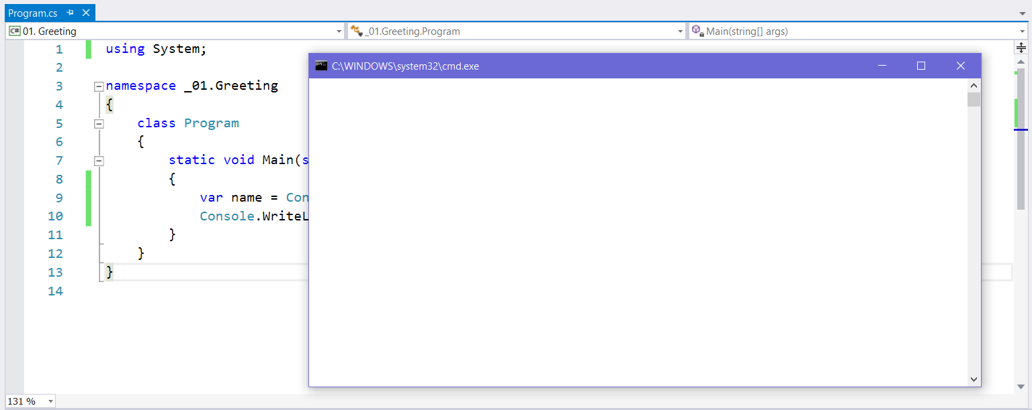

Let’s **type in** a name and see if it works:

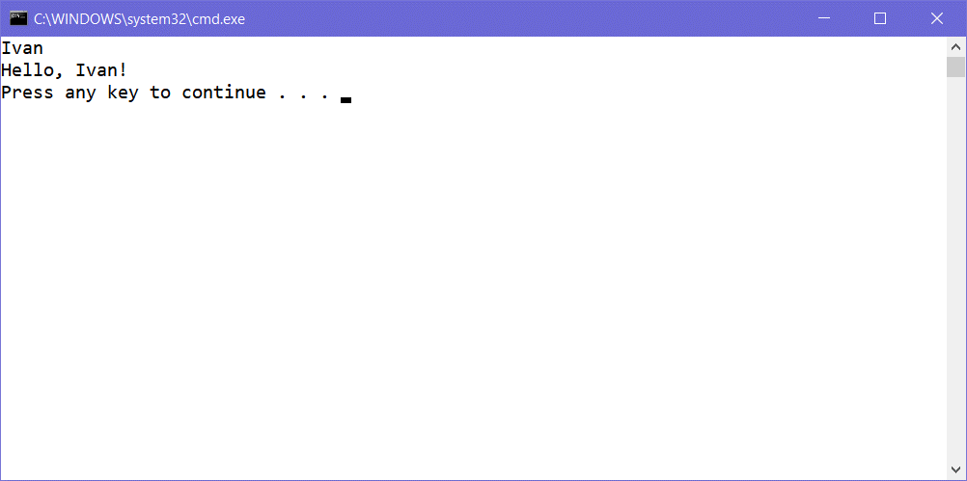

If you followed all the steps correctly, you should be greeted by your program! Submit the code in **Judge** and test if it works correctly.

### Examples

|  |  |
| --- | --- |
| **Input** | **Output** |
| Pesho | Hello, Pesho! |
| Ivan | Hello, Ivan! |
| Merry | Hello, Merry! |

## Add Two Numbers

Write a program, which **reads 2 whole numbers** and **adds** them together. Then, print them in the following format:

* “a + b = sum”

### Create a New C# Project Inside the Solution

In **Visual Studio**, create a new project in our **current solution** by **right clicking** the **solution** in the **Solution Explorer** and navigating to **[Add 🡪 New Project…**]:

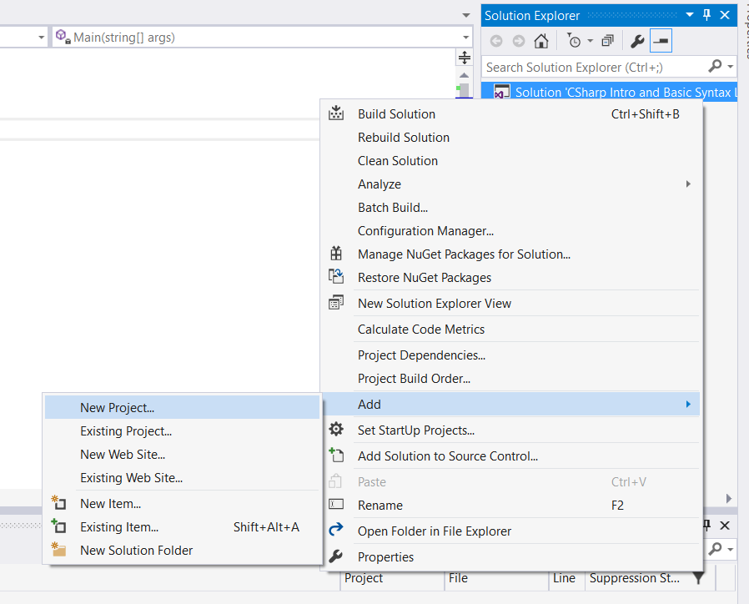

After that, name it appropriately and hit **[OK]**:

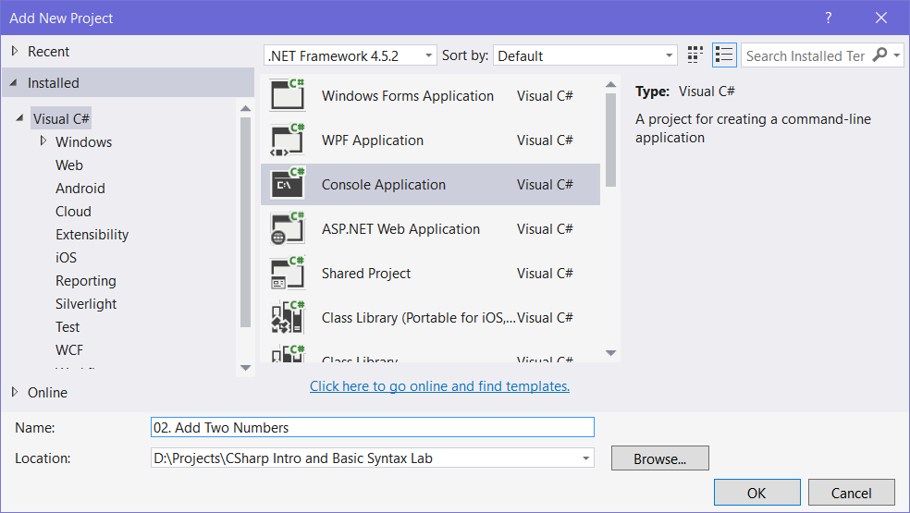

### Change the Startup Project

Now that you’ve created a new project inside the solution, you need to **set** **the startup project to the currently selected project**, otherwise whenever you hit **[Ctrl+F5]**, the **previous problem** will start. So **right click** the **solution** and hit “**Set Startup Projects”**:

|  |  |  |
| --- | --- | --- |
|  | 🡺 |  |

Now we’re ready to write our logic.

### Examples

|  |  |
| --- | --- |
| **Input** | **Output** |
| 2  5 | 2 + 5 = 7 |
| 1  3 | 1 + 3 = 4 |
| -3  5 | -3 + 5 = 2 |

## Employee Data

Write a program to read **data** about an **employee** and print it on the console with the appropriate formatting. The order the input comes in is as such:

* Name – **no** formatting
* Age – **no** formatting
* Employee ID – **8-digit padding** (employee id 356 is 00000356)
* Monthly Salary – formatted to **2 decimal places** (2345.56789 becomes 2345.56)

### Examples

|  |  |
| --- | --- |
| **Input** | **Output** |
| Ivan  24  1192  1500.353 | Name: Ivan  Age: 24  Employee ID: 00001192  Salary: 1500.35 |
| Peter  30  113236  1738.1112 | Name: Peter  Age: 30  Employee ID: 00113236  Salary: 1738.11 |
| Naiden  27  1111222  3560 | Name: Naiden  Age: 27  Employee ID: 01111222  Salary: 3560.00 |

### Hints

* You can use “D” and “F” to format numbers in C#. You can read more about formatting strings [here](https://msdn.microsoft.com/en-us/library/dwhawy9k(v=vs.110).aspx).